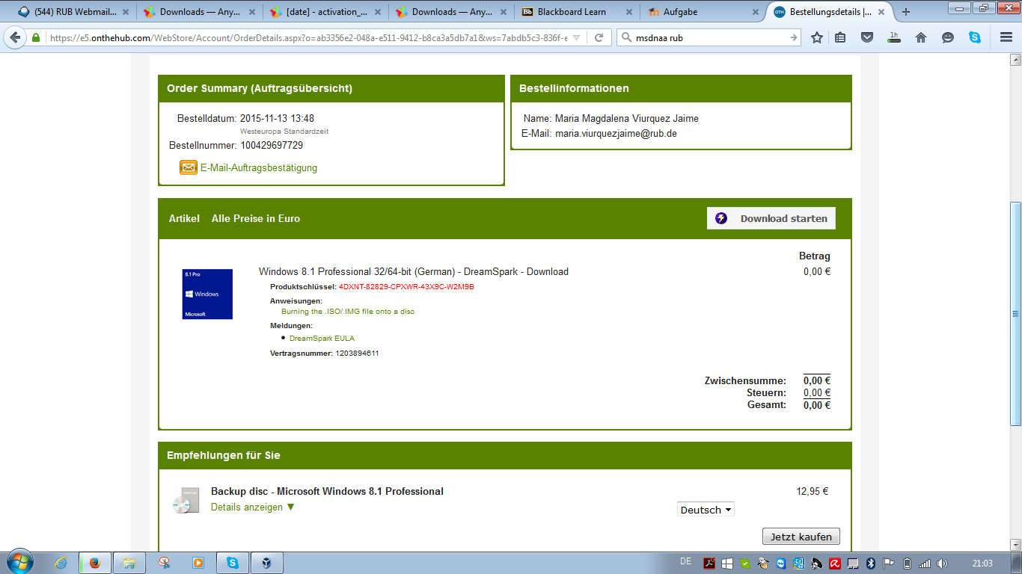

|  |  |  |
| --- | --- | --- |
|  | Windows 8.1 Professional 32/64-bit (German) - DreamSpark - Download  **Produktschlüssel:** 4DXNT-82829-CPXWR-43X9C-W2M9B  **Anweisungen:**  [Burning the .ISO/.IMG file onto a disc](https://e5.onthehub.com/WebStore/Common/DisplayTextPropertyText.aspx?vs=44f78bc5-ffdc-e311-93fd-b8ca3a5db7a3&pt=19&pttk=WebStore.Instructions&ws=7abdb5c3-836f-e011-971f-0030487d8897&vsro=8)  **Meldungen:**   |  | | --- | | • [DreamSpark EULA](https://e5.onthehub.com/WebStore/Common/DisplayOrderMessage.aspx?oiomr=b03356e2-048a-e511-9412-b8ca3a5db7a1&o=ab3356e2-048a-e511-9412-b8ca3a5db7a1&ws=7abdb5c3-836f-e011-971f-0030487d8897&vsro=8) |   **Vertragsnummer:** 1203894611 |

